HiCLC Exam Guide (for Candidates)

**Requirements:**

1. **Environment**: Prepare an independent room and ensure that no other person enter or exit the room during the exam.
2. **Camera monitoring and desktop monitoring**: Use a computer with a camera to take the exam. It is recommended that the background be clean without any strong light or interference. During the exam, cameras will be used to monitor your behavior and computer desktops and record the screen using the AI recognition technology. If any cheating is detected, the exam will be declared invalid. If there is any other violated behavior, you will be blacklisted.
3. **Browser**: Use Google Chrome 58.0 or later during the exam. Other browsers (such as Edge and Firefox) may be incompatible.
4. **OS**: Windows 7 or later
5. **Network**: The network speed must be greater than 256 kb/s.
6. **Screen switching prevention**: Before the exam, you must exit applications that may display notifications, including the chatting, email, office, translation, and alarm software, as well as screen saver, so that no message will be displayed and regarded as screen switching. A maximum of three times of screen switching is allowed during the exam.
7. **Test requirements**: Test your computer and environment at least two days before the exam. If the screen is switched unexpectedly due to network, browser, or software reasons, you are not allowed to take the exam for the second time for free.

**Exam authorization code: 9598D**

**Test link:**https://enclass.hiclc.com/portal/#/community/college/hc-en?t=0&r=0&b=1&s=1&id=70ae1440-046f-7acb-4e3b-13593c35588e&page=1

**Other issues:**

1. The network quality may affect the system's decision on screen switching; therefore, ensure your exam computer has stable network connections.
2. If any network or hardware fault is detected when testing the exam computer, replace the computer and test again immediately.
3. Your Exam behavior will be identified and recorded in WeLink(Conference system).

**Part 1 Starting a Video Conference**

When receiving a notification indicating that an exam is scheduled successfully, you will also receive a conference link. Click **Join (External)**. The following is an example:

Step1: Right-click in the Invigilates link, click Copy the hyperlink to the Chrome browser (Chrome and Edge browsers are supported ) and access the website

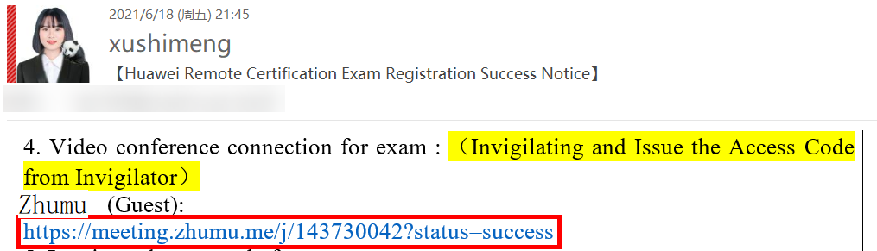

Step2： On the pop-up page, click Download and Install the conference application

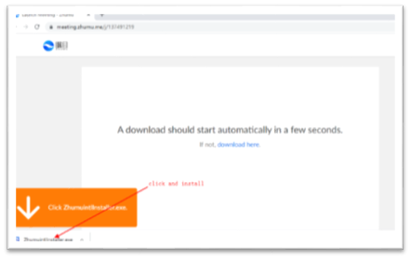

Step3： After the installation was done, close the registration/login pop-up window. (Registration and login are not required.)

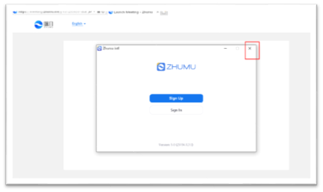

Step4： Open the meeting invitation email, Right-click the meeting link, click Copy the hyperlink to the Chrome browser (only Chrome and Edge browsers are supported ) and open the conference

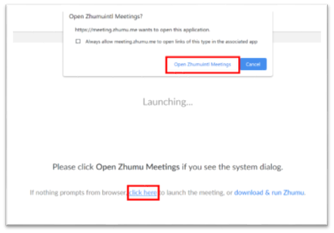

Step5: Follow the steps you can join the conference

**Notes：After you join the video conference, please change your name to the name for registering for the exam.**

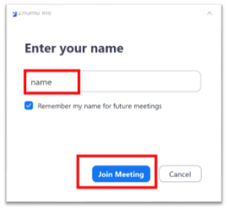

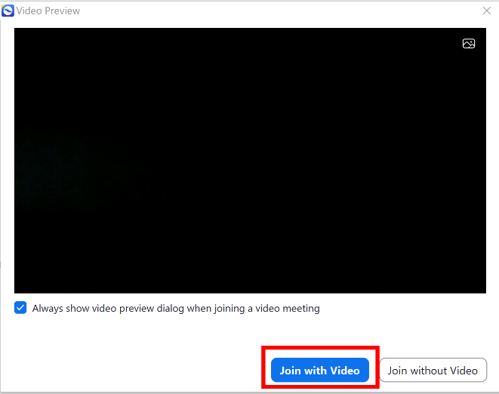

Step5: After joining the meeting, turn on the camera and microphone, and share the screen.

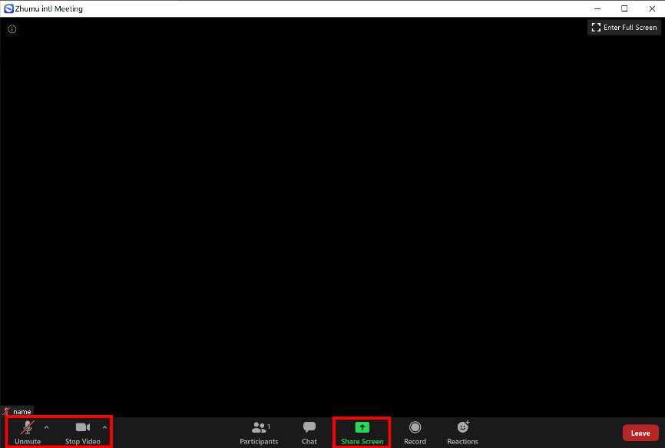

If you are Huawei staff and cannot join the meeting as usual

1、 If you are not in a Huawei office, disconnect the IAccess, suspend the access to the intranet, and connect the conference again.

2、 If you are in a Huawei office and cannot directly connect to the public network, you can directly contact the candidate through the Huawei email address WeLink/eSpace to initiate a conference invigilation.

3、 As an intranet user, open the WelinkMeeting and enter the conference ID (0 + 10 digits). The conference ID is displayed in the email notification connection.

**Notes：After you join the video conference, please change your name to the name for registering for the exam.**

**Part 2 Starting the Exam**

Enter the exam page 30 minutes before the time specified in the email about successful reservation. Prepare your original passport. A proctor will verify your identity online. After that, log in to the exam center to test your exam account. If you have any questions about logging in to the system, please contact the proctor.

Open and login to the following exam link.

Login URL: <https://enclass.hiclc.com/portal/#/community/college/hc-en>

(Caution!) Click the Huawei logo and log in to the system using the Uniportal account.

If you do not have a Uniportal account or forgot your password, see Attachment（End of this Doc.）*: Huawei Uniportal Registration Guide*.

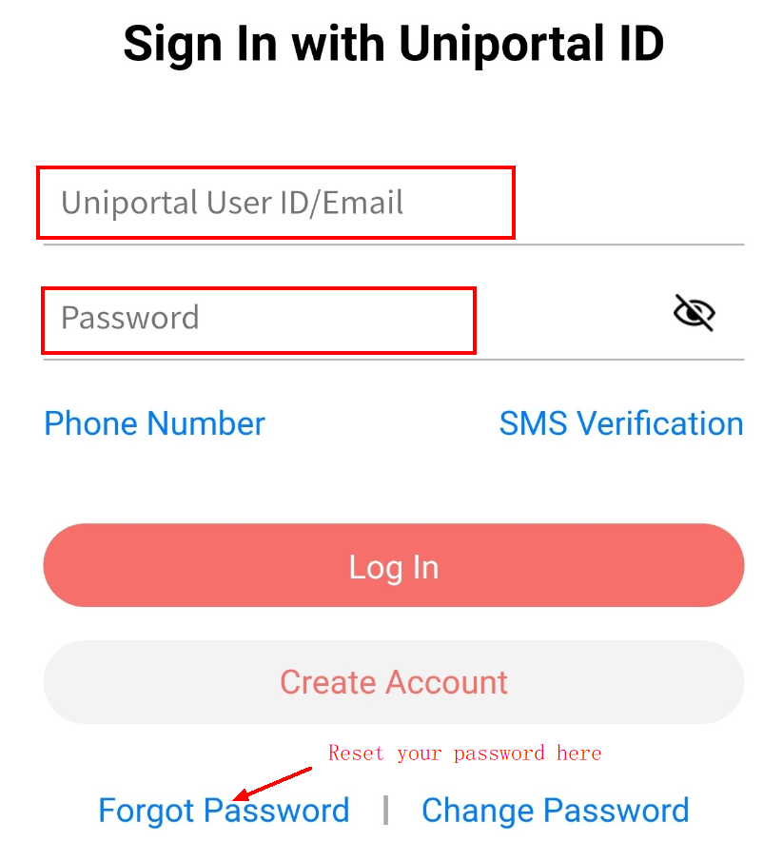

Please login here

With your Uniportal account

After login, **Huawei Certification Examination** is displayed on the upper left corner and your account is displayed on the upper right corner.

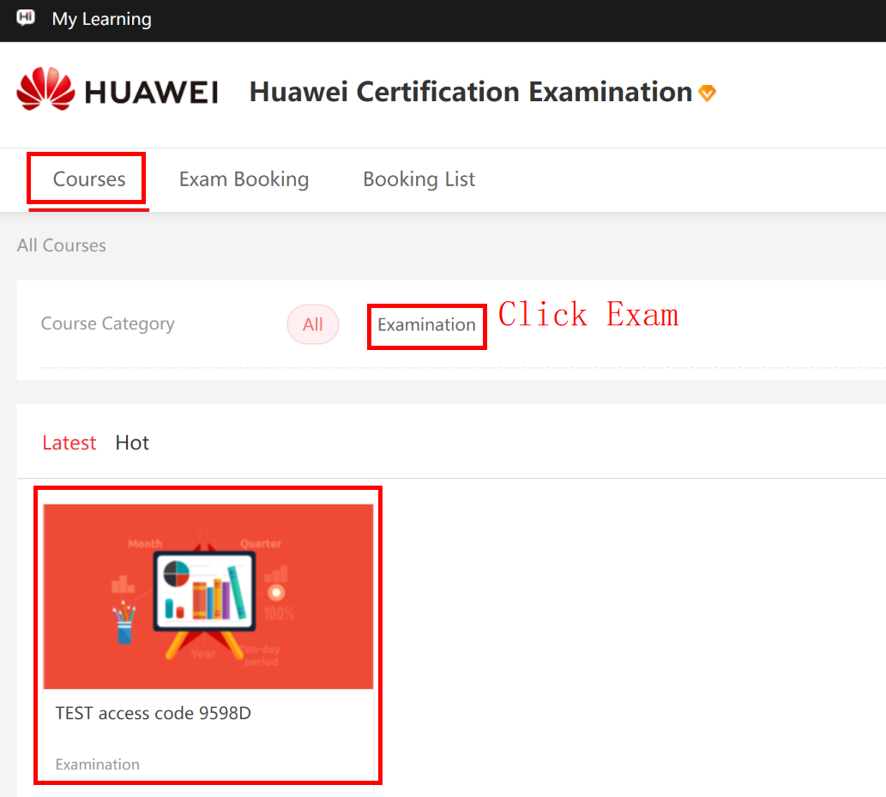

Click **Huawei Certification Exam** in the upper left corner to view the exam to be signed up.

Select your online exam and click the icon to enter the exam.

If the exam subject is incorrect, contact the proctor.

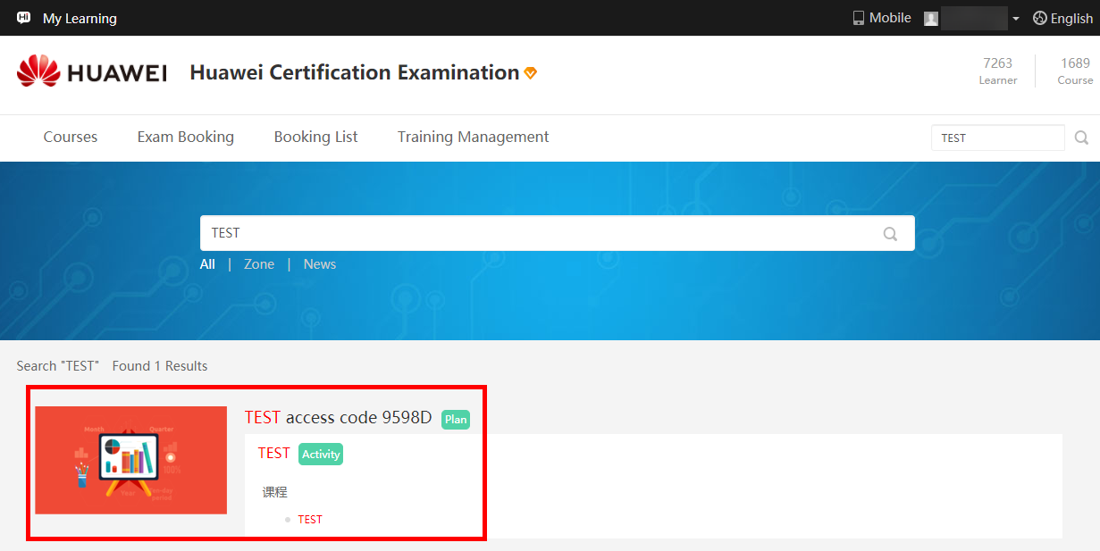

Start the exam. Specifically, click the correct exam ID, check the exam number, and click **Enroll** to sign up.

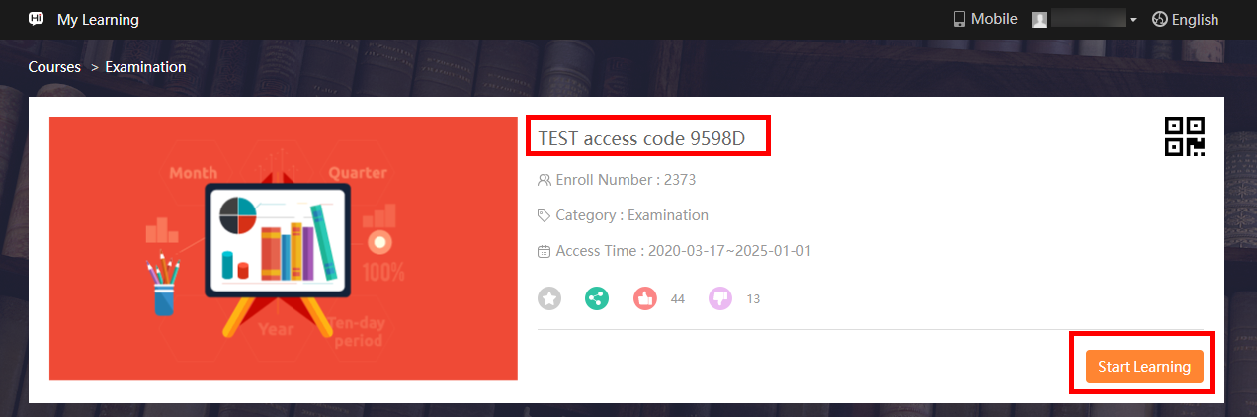

Enter the exam access code (obtained from the **proctor**).

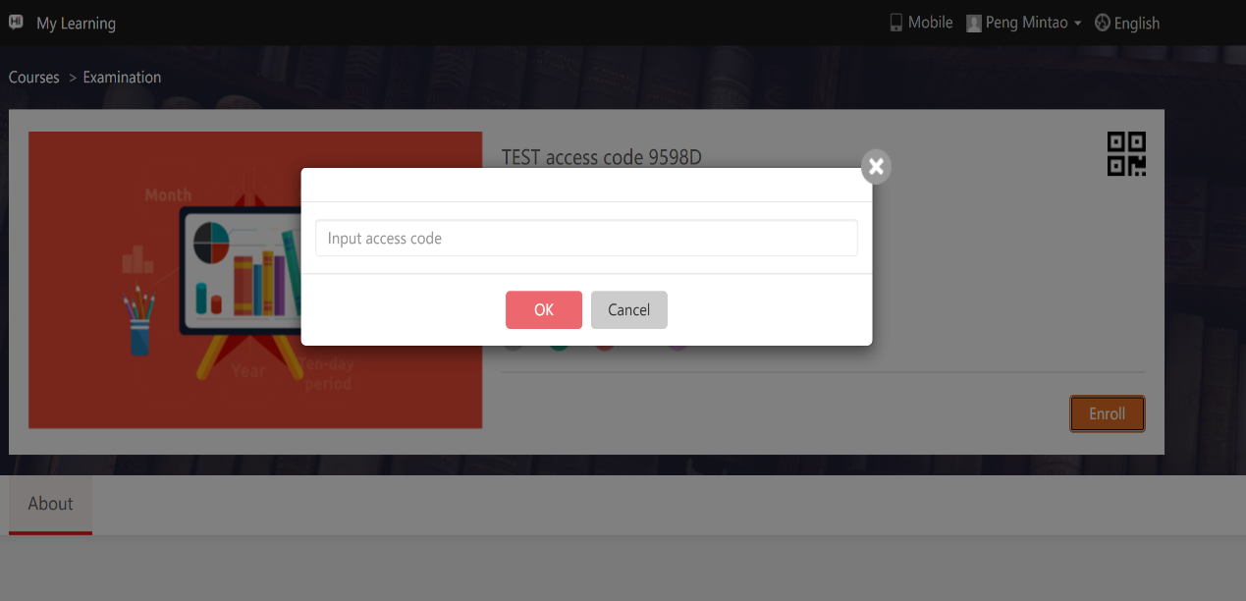

**9598D**

Click **OK**.

Start the exam at scheduled time.

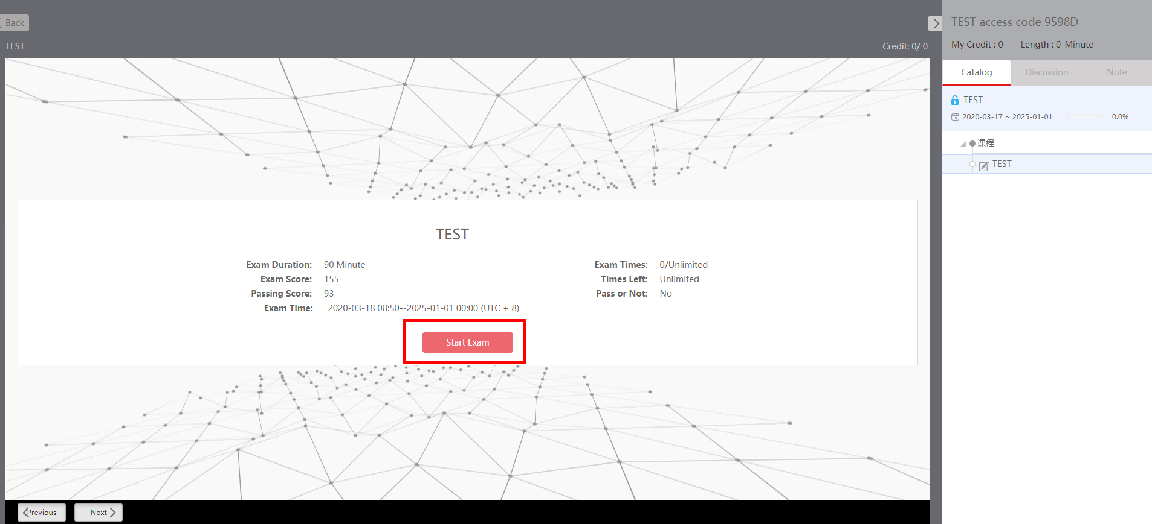

After the exam is complete, click **Submit** in the upper right corner.

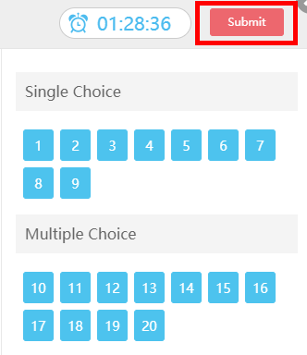

Check the information in the prompted dialog box and click **Submit**. (Note: You are not allowed to click **Submit** until 20 minutes after the exam starts.)

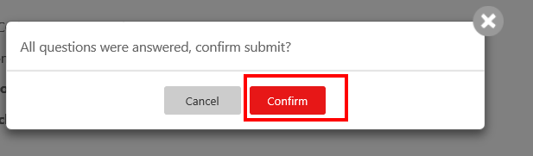

After you submit the exam, the system displays your score and whether you pass the exam.

If you do not remember the passing score, check with the proctor or Huawei training manager.

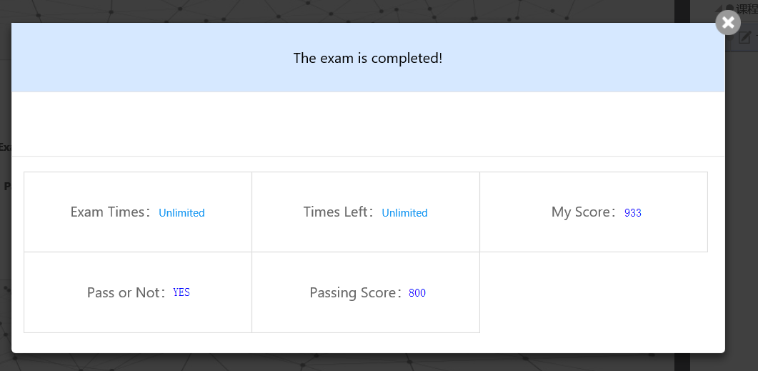

----End

**Part 3 After the Exam**

If you pass the exam, you will receive an email from certification@huawei.com within 5 working days after the exam. If you do not receive this email or have any questions about your exam, contact us at [certification@huawei.com](mailto:certification@huawei.com) or training manager.

**Part 4 Downloading Your Certificate**

If you have passed the exam and are qualified to obtain the certificate, download the certificate from the following link:

<https://e.huawei.com/cn/talent/#/admin/mycertificate>

## Attachment： Huawei Uniportal Registration and Reset password Guide

**【Note: Skip this step for Huawei and partner employees.】**

**Note: This guide helps you register an authenticated account on the Huawei official website. At the website, accounts are identified with e-mail addresses. Therefore, you are advised to use your daily email address for registration.**

Click the following link and create a Huawei account on the official website.

Huawei account registration link: <https://uniportal.huawei.com/accounts/>

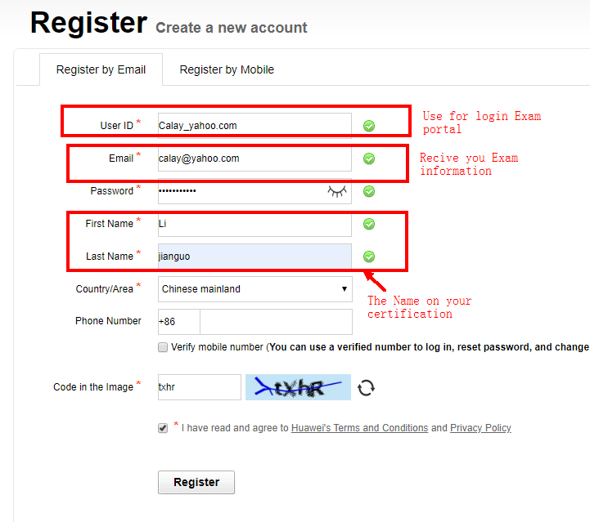

huawei.com

Please check your email and click on the link to activate your account..

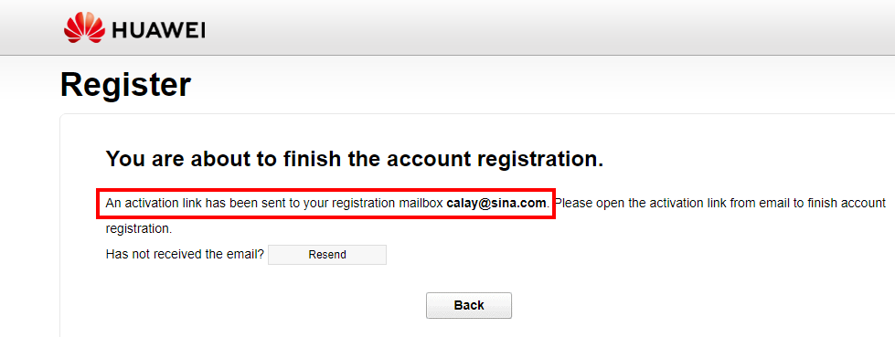

Reset you Password: if you forgot you Password of huawei Uniportal account，please reset your password :

Please click for Forgot Password as the following figure：

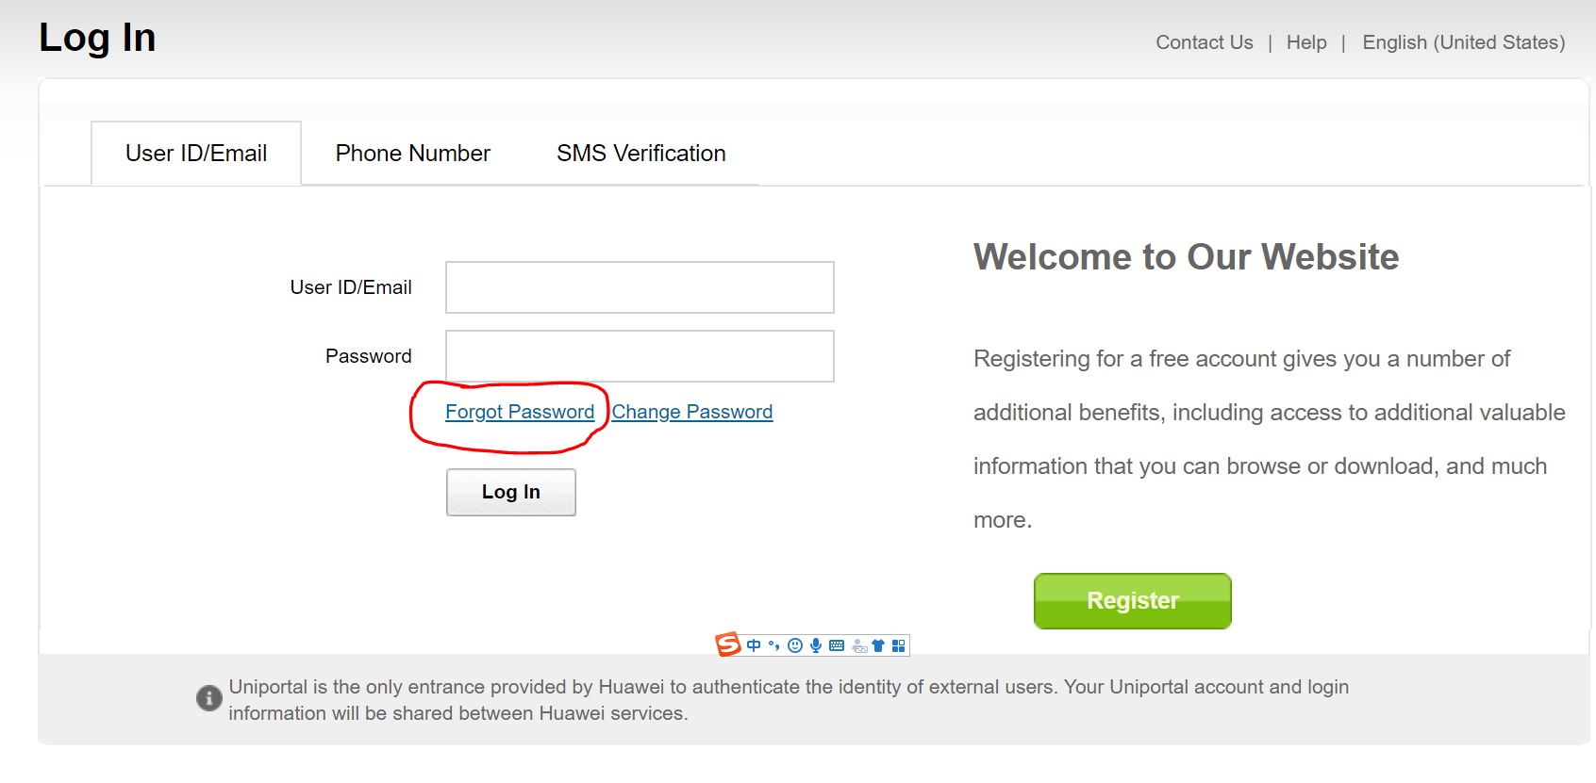

Please input you Email address registered on the Uniportal as the following figure, and input correct verification code：

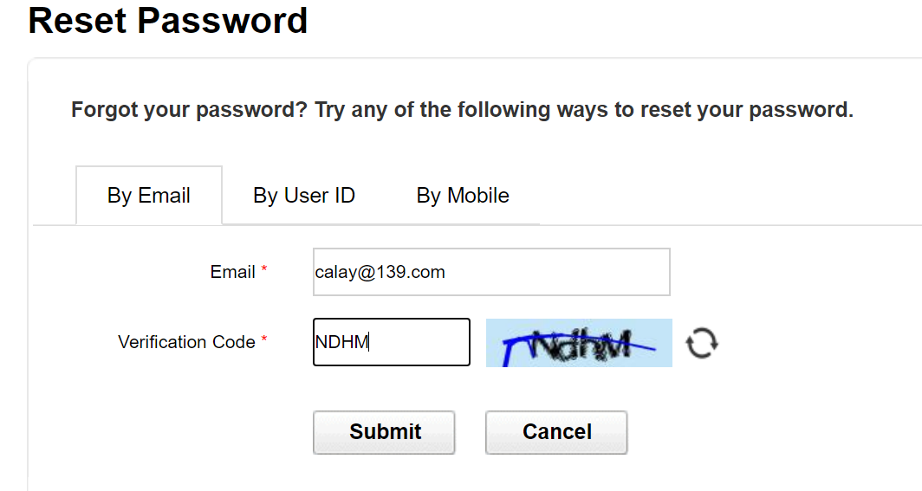

Check your email and click the reset password link to reset your passrod：

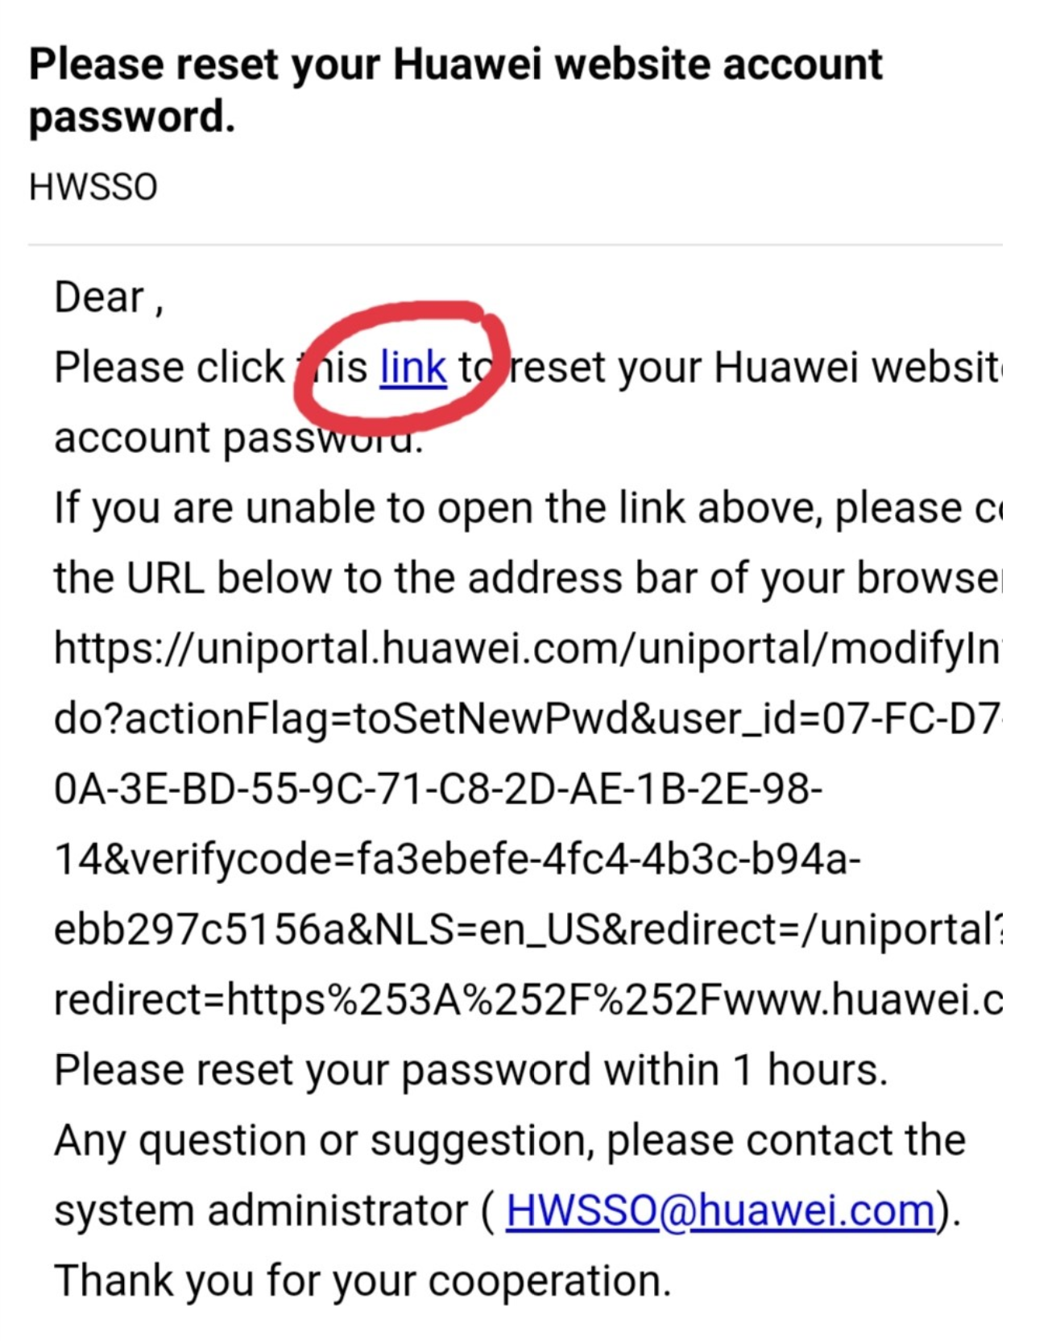

----End